COSC 4377 – Networking - Kevin B Long

# 

# **Homework #1**

Due 11:59am, Sunday, 27 January 2019

Multiple submissions accepted.

We will begin our homeworks with a pair of Wireshark labs. You have access to the Word versions of these documents, into which you can paste screenshots and answers sufficient to prove you did the work. A best practice is to include one screen with Wireshark running and part of a page from UH showing you are logged in as you, and the timestamp showing. That’s also very helpful if and when Blackboard eats your homework (hides it from us, really) which it does to many students at least once a semester.

1. (10 pts) Do the Intro Wireshark lab found in the Wireshark folder on the google drive. The document is available as a Word document – you may paste your answers into that document and paste the entire document including your answers here, or ZIP that file with this one to upload to BlackBoard.
2. (25 pts) Complete the second Wireshark lab on HTTP. A note: if you have trouble seeing the packets you need on your network to complete your exercise (if Wireshark is working but they’re just not there), then you can simply open the provided “pcap” file from within Wireshark to load packets that we captured previously. I’ve added a folder of those to the class drive.
3. (10 pts) The FCC began auctioning off 5G spectrum last November. Using the information you can find beginning at <https://www.fcc.gov/5G>, answer the following questions.
   1. (1 pts) From what bands were frequencies auctioned in the first round?

___28GHz to 24GHz_______________________

* 1. (1 pts) Which of these was auctioned off first, and what was the name of that round?

__28 GHz, Auction 101________________________

Visit <https://www.fcc.gov/auctions>, and select your auction. Find the results tab.

* 1. (1 pts) Is the auction ended or continuing?

___The auction ended today (January 24th)_______________________

* 1. (1 pts) What’s the total amount of provisionally winning bids so far?

_$702,572,410 with a total of 2,965 28 GHz UMFUS licenses won__

* 1. (2 pts) Harris County (where we live) is not one of the counties whose 28GHz spectrum is being auctioned. In fact, about 75% of the US population lives in counties not included in this auction. Why did the FCC not auction them? Cite your source(s) and explain.

Verizon Wireless purchased Straight Path communications in 2017, this company owned the ~75% of US 28GHz spectrum and is the reason why the auctioned spectra only covered 23.7 of the country.

Source: https://www.fiercewireless.com/5g/editor-s-corner-why-28-ghz-spectrum-auction-only-covers-23-7-u-s-population

* 1. (2 pts) If someone can’t bid on the 28GHz spectrum, does that mean they can’t offer 5G? Why or why not?

They could, the 5G uses frequencies in the millimeter range, 30 to 300 GHz. So someone who didn’t bid on 28GHz could still bid on 32GHz of some other frequency in the 30-300 range that is unowned.

* 1. (2 pts) Consult the Frequency Allocation chart “[FCC 2003] FCC 2003-allochrt.pdf” in the “Articles & Reading Assignments” class folder, and report what one of the 5G auctioned spectrum bands, **24GHz**, is being used for today. Include a zoomed-in snapshot to show what the allocation chart shows at that frequency. You usually can rotate images in word to make them fit better ☺

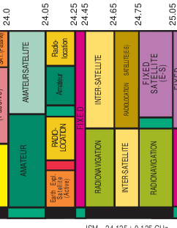

(22 pts) Peering – In the table below, we’ve listed a number of Internet domain names and something called an “AS number” (more on that later in the semester). We can learn some things about who’s hosting services for a domain by looking up their information on special web sites. One of the most important tools for doing this is a DNS database. In this problem, we’ll look up who that is for each domain, and then we’ll see to how many other networks they directly connect. It’s a sign of both how popular they are but also how well-connected they are (no pun intended), which makes their services appear closer to lots of users.

1. (11 pts) Use <https://mxtoolbox.com/DNSLookup.aspx> or another similar tool to find the AS number registered for each of the sites below. One by one, enter the domain name below from the table into this web page, and in the IP Address column you should see in small print the name of the organization hosting that domain, and after it in parentheses, their AS #. Write that number down in this table, and the name of who is hosting the site in the Hosted by column. Leave # Peers for blank for now.

|  |  |  |  |
| --- | --- | --- | --- |
| Site / Sitio | AS # | Hosted by | # Peers |
| www.uh.edu | AS7276 | University of Houston | 0 |
| houstontx.gov | AS32457 | City of Houston | 1 |
| ietf.org | AS3356 | Level 3 Communications, Inc | 157 |
| www.org | AS3 | Massachusetts Institute of Technology | 11 |
| astros.com | AS11251 | Major League Baseball Advanced Media, LP | 2 |
| nytimes.com | AS54113 | Fastly | 223 |
| chron.com  (the Houston Chronicle) | AS33070 | Rackspace Hosting | 0 |
| txprof.com | AS26496 | GoDaddy.com | 42 |
| amazon.com | AS16509 | Amazon.com, Inc. | 360 |
| whitehouse.gov | AS16625 | Akamai Technologies, Inc. | 8 |
| americamovil.com | AS19324 | Dosarrest Internet Security LTD | 52 |

1. (11 pts) We saw qratorlabs in class when looking at how well-connected sites were to Tier 1 backbone providers. But peering is also important – the degree to which you connect to other organizations in a similar place in the hierarchy as you.

Use qratorlab’s AS Rating tool [https://radar.qrator.net/as-rating#connectivity/1](https://radar.qrator.net/as-rating" \l "connectivity/1), find the “peering” link on the left and then enter the AS number from the table for each of the rows and record the number of peers.

1. (10 pts) Consult the following article on utility markings: “<https://wamu.org/story/18/06/19/secret-language-sidewalk-decoding-utility-graffiti/>”

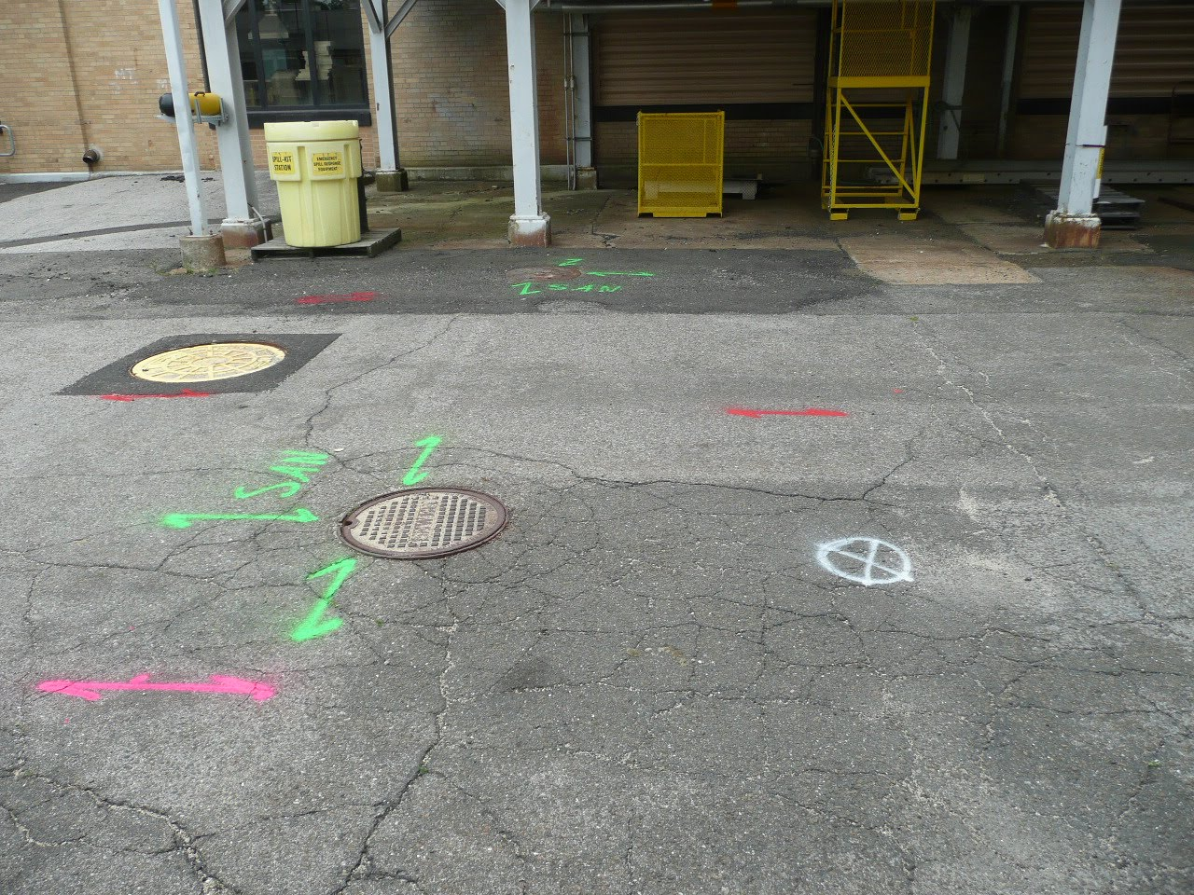

1. (3 pts) In the photo above, what services can you identify as having been marked and using what colors?

According to the picture in the article: Green is sewer, the red is electric line, purple is a termporary survey and the white Proposed excavation.

1. (2 pts) Where does the construction crew wish to dig?

At and around the white circle

1. (2 pts) There are three green arrows. What is the significance of three?

There is a T joint connecting under the man hole. The pipe extends in those three directions

1. (3 pts) Find a different photo on the Internet. You will also find several photos you may use in the homework #1 folder on our class drive. Assume all markings are to the US standard. This wikipedia article will help: <https://en.wikipedia.org/wiki/Utility_location>

Insert the photo here and **list the services that have been marked**.

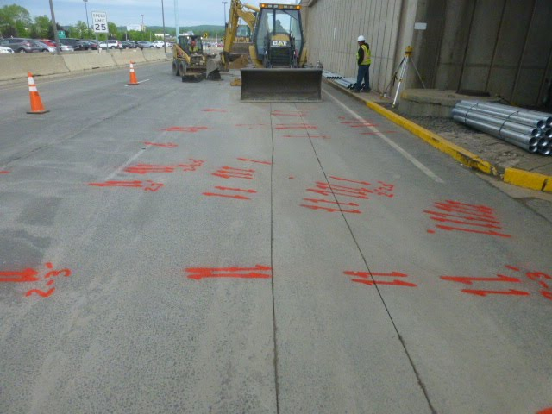

Services marked (list color and meaning):

The red signifies that these are electrical vales of some sort under the road. Arrows signify that the utility line continues outside of the marked area (though not necessarily in that direction). The electrical utilities indicated by these markings are 2 to 3 feet wide.

|  |  |
| --- | --- |
| Red | [electric power lines](https://en.wikipedia.org/wiki/Electric_power_transmission), cables, conduit, and lighting cables |
| Orange | [telecommunication](https://en.wikipedia.org/wiki/Telecommunication), alarm or signal lines, cables, or conduit |
| Yellow | natural gas, oil, steam, petroleum, or other gaseous or [flammable](https://en.wikipedia.org/wiki/Flammable) material |
| Green | sewers and drain lines |
| Blue | drinking water |
| Purple | [reclaimed water](https://en.wikipedia.org/wiki/Reclaimed_water), irrigation, and [slurry](https://en.wikipedia.org/wiki/Slurry) lines |
| Pink | temporary survey markings, unknown/unidentified facilities |
| White | proposed excavation limits or route |

Internet Standards

1. (2 pts) How many RFCs exist? Make sure it’s a current count from a source who might actually create the list. Cite your source (include the link).

8514: https://www.ietf.org/download/rfc-index.txt

1. (21 pts) According to [**RFC1410**](https://www.rfc-editor.org/rfc/rfc1410.txt),
2. (4 pts) What two categorizations does an RFC have?

Maturity level (state of standardization) and requirement level

1. (5 pts) What are the various values of the first categorization?

Standard, draft standard, proposed standard, experimental, informational and historic

1. (4 pts) Can you find a recent RFC for each of the values of this first categorization? List the RFC # and the value of the category (e.g. RFC #1 – defunct, etc.)

Standard: 0020 (ASCII format for network interchange)

Draft Standard: 0951 (Bootstrap Protocol)

Proposed Standard: 0977 (Network News Transfer Protocol)

Experimental: 0998 (NETBLT: A bulk data transfer protocol)

Informational: 1012 (Bibliography of Request For Comments 1 through 999)

Historic: 1021 (High-level Entity Management System (HEMS))

1. (4 pts) What are the various values of the ***second*** categorization?

Required, recommended, elective, limited use and not recommended

1. (4 pts) According to RFC 1410, if you graph the two categories on axes of a matrix, in which column-row pairs are new protocols most likely to start?

proposed standard, elective